Page **0** of **21**



**This manual is copyright to the Oceanway Corporation Limited. Obtain permission before using it. Contact** [**:Paul@hkocl.com**](mailto:Paul@hkocl.com)

UNDERWATER ROV CONSTRUCTION MANUAL

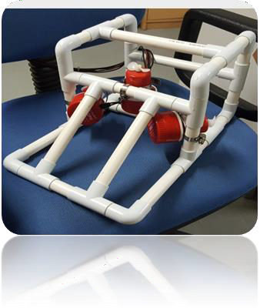

**ROV 3**

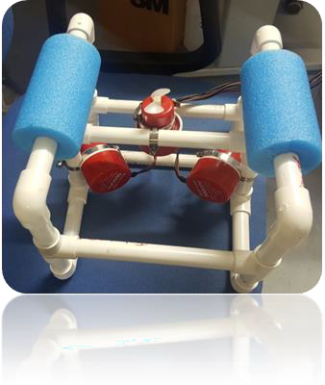

**ROV 1**

Basic ROV

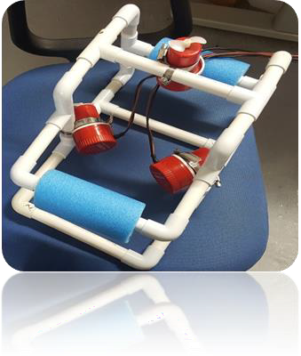

**ROV 2**

Science ROV

Battle ROV

**Introduction**

This manual describes the construction of 3 basic Underwater Remotely Operated Vehicles (ROV). Each ROV design has a different function and use. The frames described can be modified for competition purposes. For example, the basic ROV frame is a suitable training platform for the MATE Underwater Robotics Competition.

The skills gained from the construction of the ROV are based upon Science, Technology, Engineering & Math (STEM). The course that accompanies this manual is based upon giving students an experiential learning experience. This way a student’s creativity, ingenuity & conceptual awareness can be encouraged.

For teachers, expanding the uses of the 3 ROV described encourages this technology to be introduced into mainstream teaching. For example, adding a water sampling unit and simple mud grab allows students to use the ROV to collect water samples and mud samples for later analysis.

This ties together the fields of Engineering & Ecology in a way that is not beyond the capability of a student.

**Contents**

**UNIT 1A** – ASSEMBLY OF FRAME FOR ROV 1 (Basic ROV) 3

**UNIT 1B** – ASSEMBLY OF FRAME OF ROV 2 (Science ROV) 5

**UNIT 1C** – ASSEMBLY OF FRAME FOR ROV 3 (Battle ROV) 7

Procedure 1.1 – Framework Construction 9

Procedure 1.2 – Drill the Drain Holes 10

Procedure 1.3 – Attach the Payload Net (Optional) 10

UNIT 2 – ADDING *THE THRUSTERS* 11

Procedure 2.1 – Attaching motor to frame 12

Procedure 2.2– Position of motor and float on ROV frame 13

Procedure 2.3 – Connecting the Tether to the Motors 14

UNIT 3 – ASSEMBLY OF *THE CONTROL BOX* 16

Procedure 3.1 – Connecting the Tether & Motor to the Control Box 17

Procedure 3.2 – Connecting the Power Supply to the Control Box 20

USING YOUR ROV 21

# UNIT 1A – ASSEMBLY OF FRAME FOR ROV 1 (Basic ROV)

In this unit, you will cut pipe pieces and assemble the ROV frame. Holes will be drilled in the elbows and portions of the frames to allow venting and draining of the ROV frame and motor mountings later in the build.

|  |  |  |  |
| --- | --- | --- | --- |
| **Tools** |  | **Materials** | |
| Eye Protection (Always Worn) | 1.8 m of | 20 mm dia. PVC Pipe |
| Ruler and Pencil (or Marker) |  | |
|  |  |
| PVC Pipe Cutter (or Saw) | 10 | 20 mm dia. PVC Elbows |
| Wire-Cutting Pliers (Flush-Cutting | 8 | 20 mm dia. PVC Tees |
| Type Preferred) |
| Electric Hand Drill | 2 | Floats |
| ¼” Drill Bit | 1 | 310 x 170 mm Payload Net (optional) |
| 3/32” Drill Bit | 8 | 150 mm long Cable Ties |

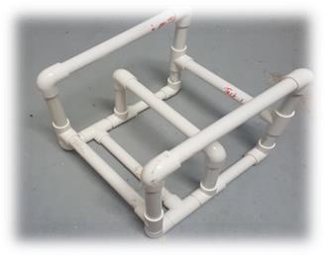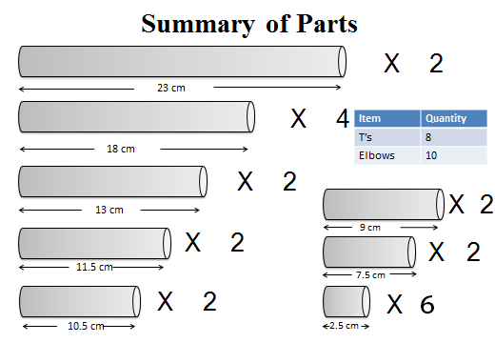

**ROV 1 (BASIC ROV)**

**Specs:**

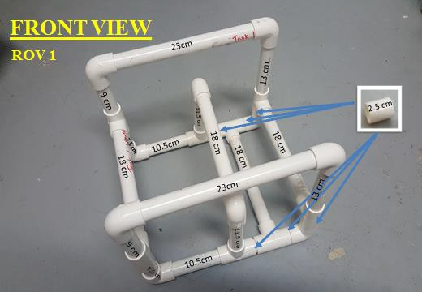

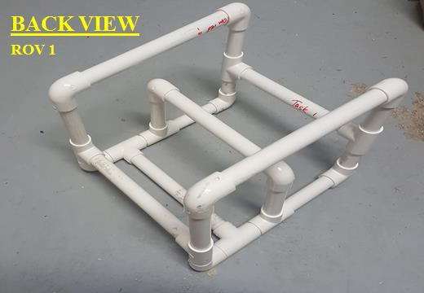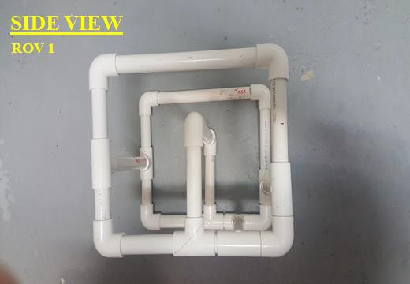

# UNIT 1B – ASSEMBLY OF FRAME OF ROV 2 (Science ROV)

In this unit, you will cut pipe pieces and assemble the ROV frame. Holes will be drilled in the elbows and portions of the frames to allow venting and draining of the ROV frame and motor mountings later in the build.

|  |  |  |  |
| --- | --- | --- | --- |
| **Tools** |  | **Materials** | |
| Eye Protection (Always Worn) | 1.8 m of | 20 mm dia. PVC Pipe |
| Ruler and Pencil (or Marker) |  | |
|  |  |
| PVC Pipe Cutter (or Saw) | 10 | 20 mm dia. PVC Elbows |
| Wire-Cutting Pliers (Flush-Cutting | 10 | 20 mm dia. PVC Tees |
| Type Preferred) |
| Electric Hand Drill | 2 | Floats |
| ¼” Drill Bit | 1 | 310 x 170 mm Payload Net (optional) |
| 3/32” Drill Bit | 8 | 150 mm long Cable Ties |

**ROV 2 (SCIENCE ROV)**

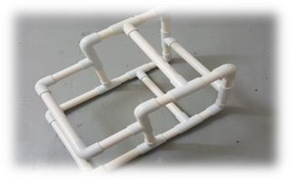**Specs:**

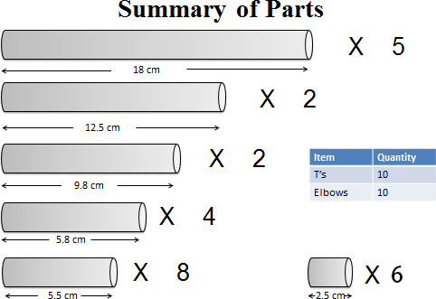

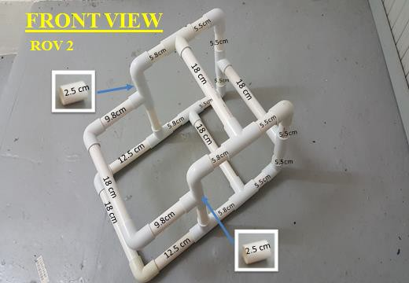

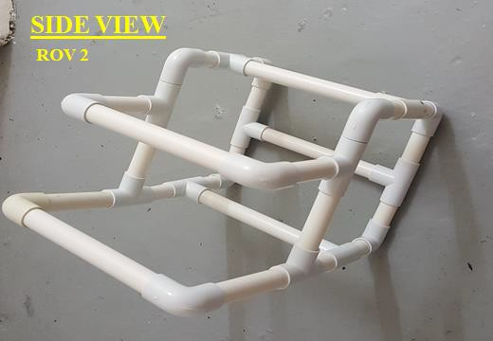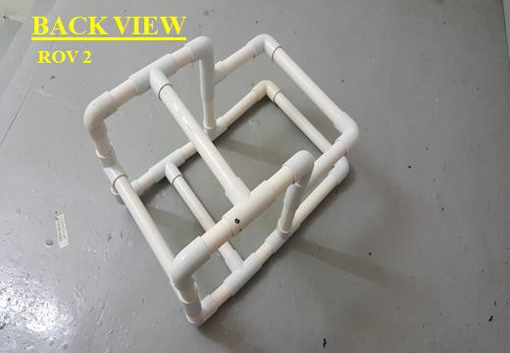

# UNIT 1C – ASSEMBLY OF FRAME FOR ROV 3 (Battle ROV)

In this unit, you will cut pipe pieces and assemble the ROV frame. Holes will be drilled in the elbows and portions of the frames to allow venting and draining of the ROV frame and motor mountings later in the build.

|  |  |  |  |
| --- | --- | --- | --- |
| **Tools** |  | **Materials** | |
| Eye Protection (Always Worn) | 1.8 m of | 20 mm dia. PVC Pipe |
| Ruler and Pencil (or Marker) |  | |
|  |  |
| PVC Pipe Cutter (or Saw) | 10 | 20 mm dia. PVC Elbows |
| Wire-Cutting Pliers (Flush-Cutting | 12 | 20 mm dia. PVC Tees |
| Type Preferred) |
| Electric Hand Drill | 2 | Floats |
| ¼” Drill Bit | 1 | 310 x 170 mm Payload Net (optional) |
| 3/32” Drill Bit | 8 | 150 mm long Cable Ties |

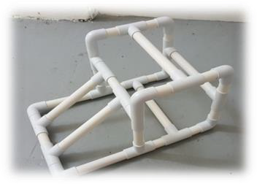**ROV 3 (BATTLE ROV)**

**Specs:**

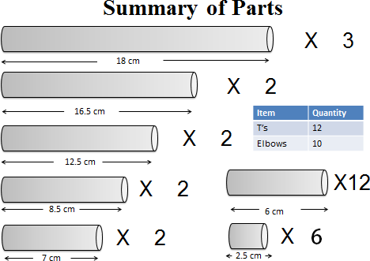

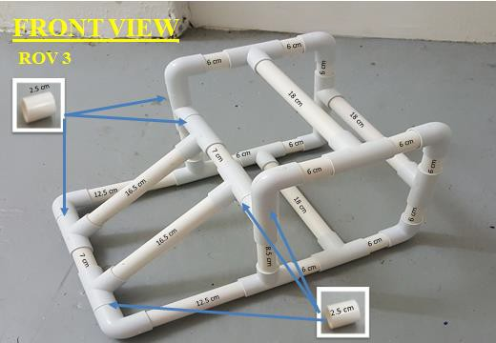

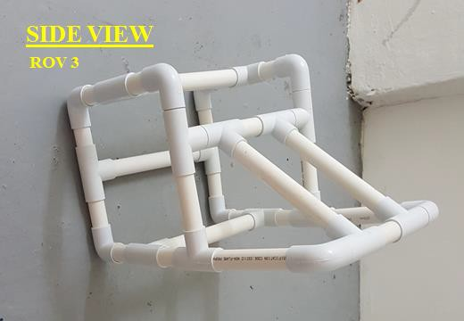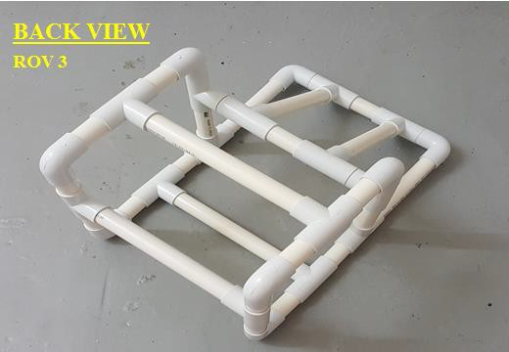

## Procedure 1.1 – Framework Construction

**Construction Steps:**

1. Measure and cut the pieces listed above. Cut the *longest* pieces *first*, in case a mistake is made (mistakes made with longer pieces can be used to be make shorter pieces). Try to cut *straight across* the pipe, but don’t worry if they are not perfect.

*Use a pencil or marker to write the length on the middle of each piece to keep track of cuts and to easily identify them later.

1. Assemble the frame using the PVC parts. *No glue is used for any of the connections.* Orient the elbows that are near the top of the vehicle with their holes pointing upward, to let air escape when the ROV is placed in the water. Orient those at the bottom with their holes pointing downward or to the side, to let the water flood in and out easily.
2. With the frame placed on the floor or on a sturdy tabletop, push down hard on all parts of the vehicle frame, turning and pressing from all sides, so that the PVC fittings and pipe sections all fit together *very tightly*. *Be sure to press HARD, or use a rubber mallet to firmly tap on all elbows until the ends of the pipe sections bottom out inside the pipe fittings*. Adjust the sides and the bottom of the frame as needed to square up the vehicle, as shown in Figure 1.3‐2 (or tilt the sides at an angle if you wish!). **It is important to do this before installing the bottom payload netting**.

**NOTE:** If you wish to paint your vehicle, do so before attaching the payload netting or thrusters, and make sure to use waterproof paint.

## Procedure 1.2 – Drill the Drain Holes

You will need to create vent and drain holes in vehicle frame in order to allow water to fill the frame when you place your ROV into the water and for the water to drain out when you remove it.

## Procedure 1.3 – Attach the Payload Net (Optional)

**Construction Steps:**

1. Place the payload net underneath the vehicle frame, and trim it to size if necessary.
2. Attach the net to the frame using about 8 small black tie wraps. Pull them tight using pliers. Make sure the net is tight and flat on the bottom of your ROV.

### DO NOT USE THE LARGE BLUE TIE WRAPS FOR THIS

1. Trim off the ends of the tie wraps using wire‐cutting pliers (as flush as possible), as shown below.

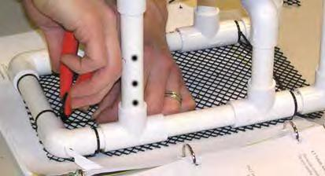

**UNIT 2 – ADDING *THE THRUSTERS***

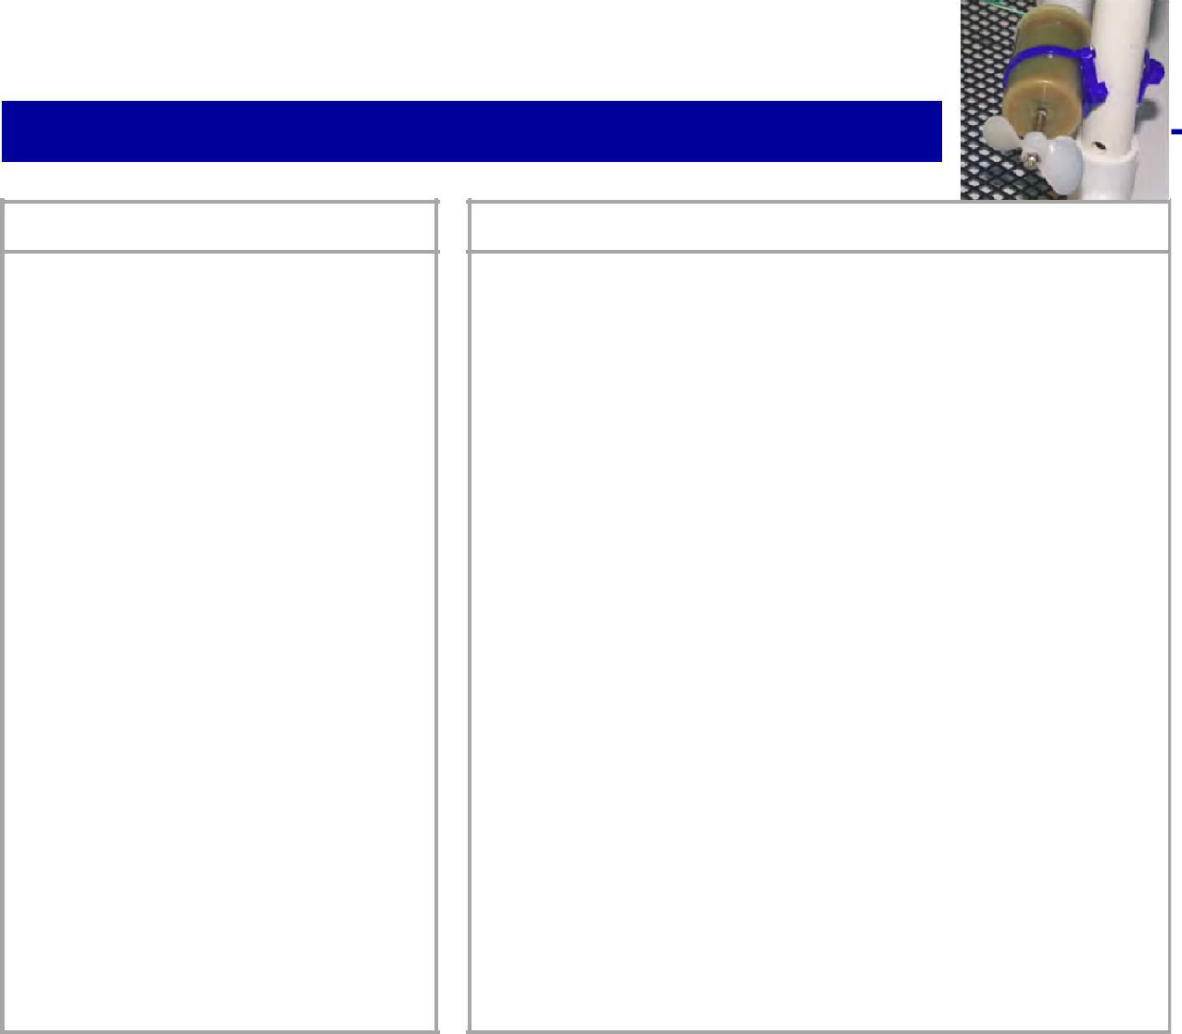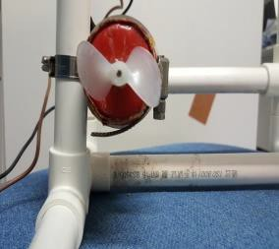

In this unit, you will learn to mount the thrusters onto the frame.

**Needed**

**Tools** Eye Protection (Always Worn)

Bit Pliers

Needle-Nose Pliers

Wire Stripper (18 - 26 AWG Size) Wire-Cutting Pliers Vise

Permanent Ink Marker Pen Ruler and Scissors Gloves (Disposable Type)

Crimping Tool

**Materials**

|  |  |
| --- | --- |
| 1 | Up to 15 m Tether Cable |
| 3 | Pump Motor Thruster with propeller attached |
| 1 | 12-Volt Battery |

8 15 cm Cable Tie

6 Medium Band clip (44 – 56mm)

6 Small Band Clip (13 – 20mm)

1 Electrical Tape

1 Battery Connection Box or Battery Clips

6 Crimps

## Procedure 2.1 – Attaching motor to frame

**Construction Steps:**

1. For each motor, it will require a small and medium band clip to hold the motor onto the frame of the ROV.
2. Place the medium band clip (44 – 56 mm) on the motor, then tuck the small band clip (13 – 20 mm) in-between the medium band clip **(See Photo 1)**
3. Tighten the medium band clips so that the small ring clip will stay in place
4. Place the small ring clip onto the frame of the ROV and tighten it
5. Note that the motors used for the side thrusters are placed at a slight angle to the direction of travel **(See photo 2)**
6. The results should look like the photos below.

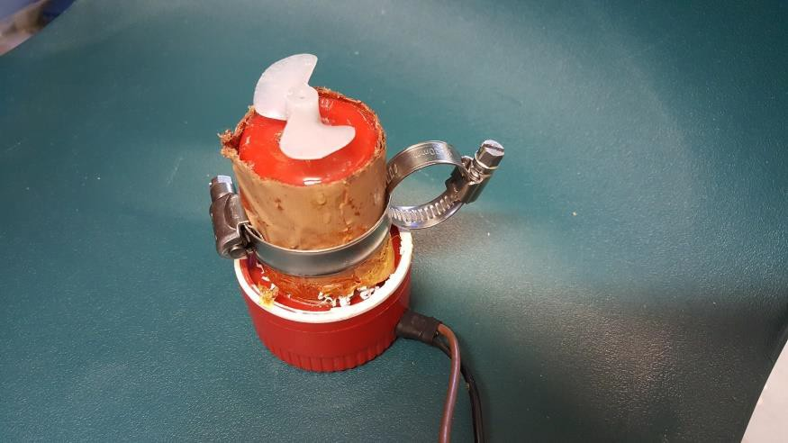

**Photo 1** - Shows how to place the medium and small ring clip onto motor

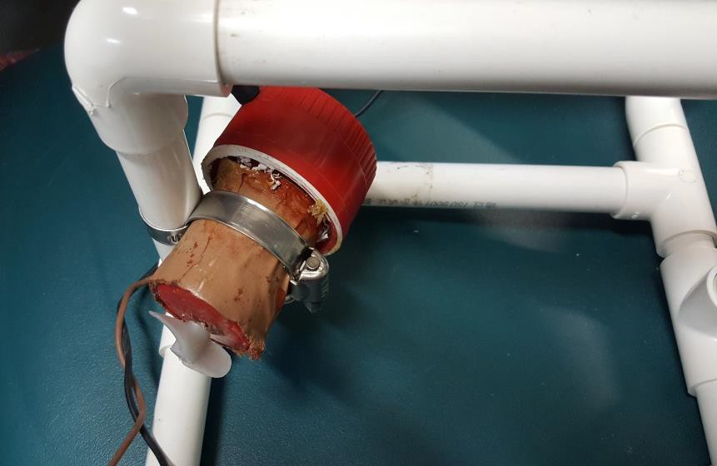

**Photo 2** - Shows to mount motor at an angle.

## Procedure 2.2– Position of motor and float on ROV frame

**BASIC ROV**

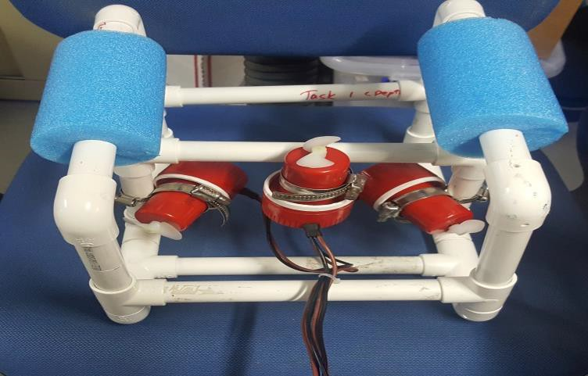 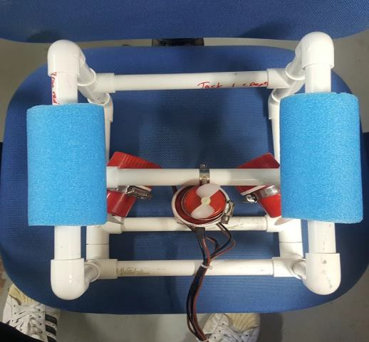

**SCIENCE ROV**

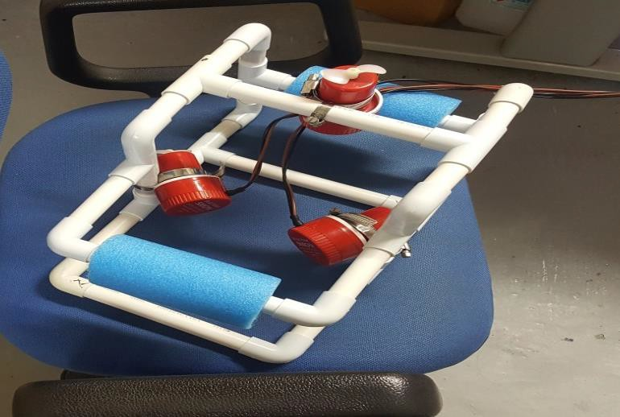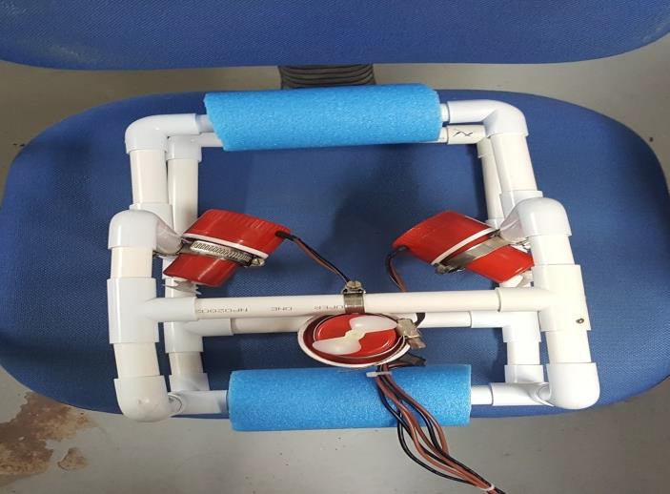

**BATTLE ROV**

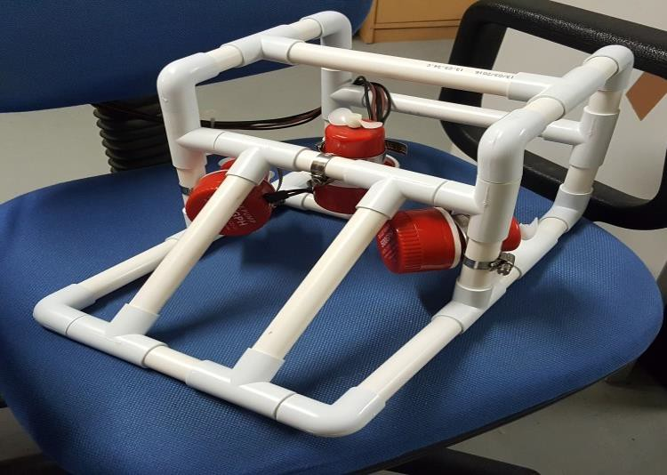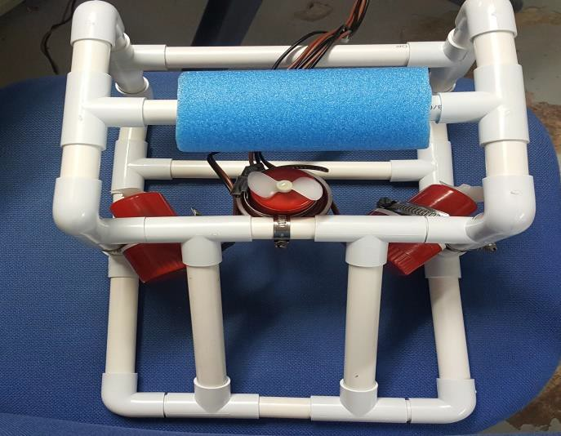

## Procedure 2.3 – Connecting the Tether to the Motors

1. The cable for the tether should have 7 wires. 1 of these wires is a spare. The numbers of each cable are shown on its coat.

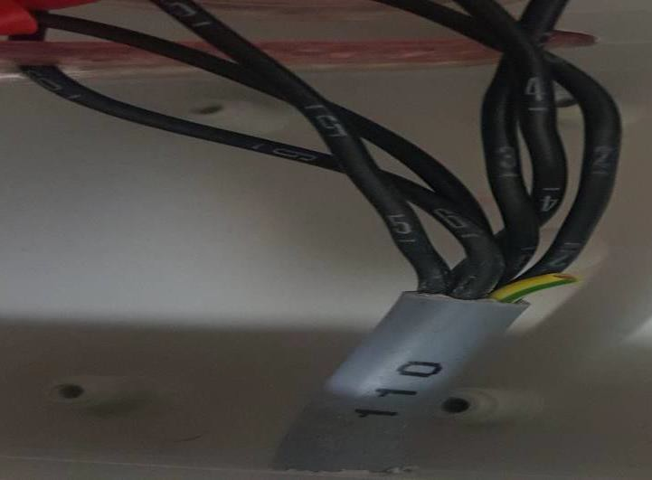

1. Connect the motors to the umbilical cable using crimp connectors.

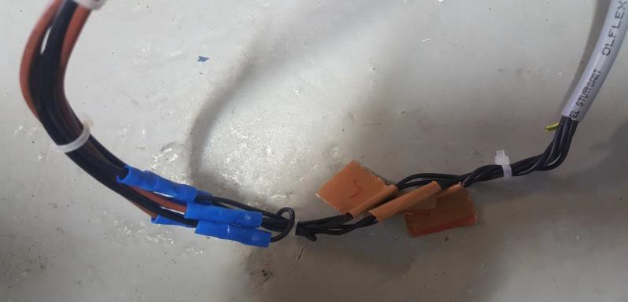

1. The following cable connection sequence is recommended

|  |  |  |
| --- | --- | --- |
| Thruster Connection | Cable Number | Remarks |
| Right Thruster + | 1 | Motor Brown Wire |
| Right Thruster - | 2 | Motor Black Wire |
| Left Thruster + | 3 | Motor Brown Wire |
| Left Thruster - | 4 | Motor Black Wire |
| Up/ Down Thruster + | 5 | Motor Brown Wire |
| Up/ Down Thruster - | 6 | Motor Black Wire |
| Spare | 7 |  |

**(Left and right with respect to the front of the frame)**

1. The cable should be attached to the ROV frame using cable ties (See photo below)

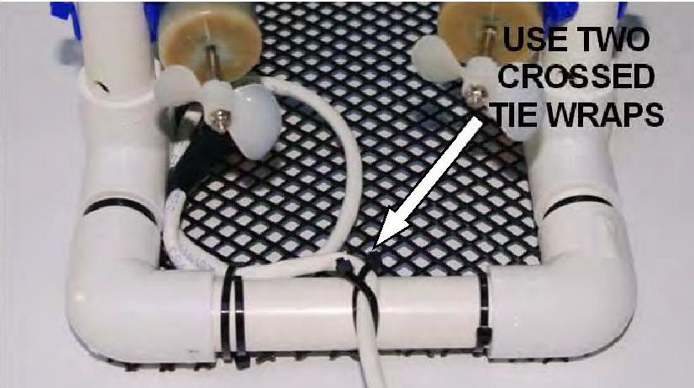

1. The end

result should look like the photo below where the cable of the motor is crimped to the tether cable. The tether cable will then be connected to the control box **(See Unit 3)**

**Tether Cable**

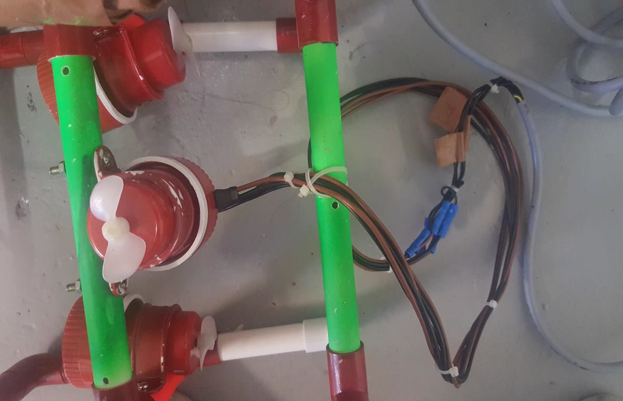

**Crimped Motor Cable and Tether Cable**

**UNIT 3 – ASSEMBLY OF *THE CONTROL BOX***

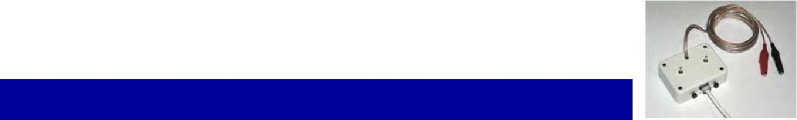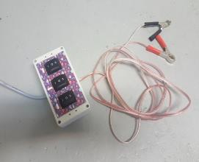

In this unit, you will build the ROV's control box by mounting electrical

components on a printed circuit board, assembling and connecting the power cord, and mounting the circuit board in the plastic control box.

**Tools and Materials Needed**

|  |  |  |  |
| --- | --- | --- | --- |
| **Tools** |  | **Materials** | |
| Eye Protection (Always | ROV Frame with Thrusters and Tether Cable Installed | |
| Worn) | 1 | Pre-Cut Control Box with Lid and Screws |
| Ruler | 3 | Rocker Switches |
|  | 2 | Alligator Clips (With Red and Black Covers) |
| Cutters | 3 | Pink Fuse (3 amps) |
| Pliers | 1 | Yellow Fuse (20amps) |
|  | 1 | 12-Volt Battery |
| Wire Stripper (18 - 26 AWG | 8 | Covered Spades |
| Size) | 18 | Uncovered spades |
| Wire Cutters |
| #2 Phillips Screwdriver |  |  |

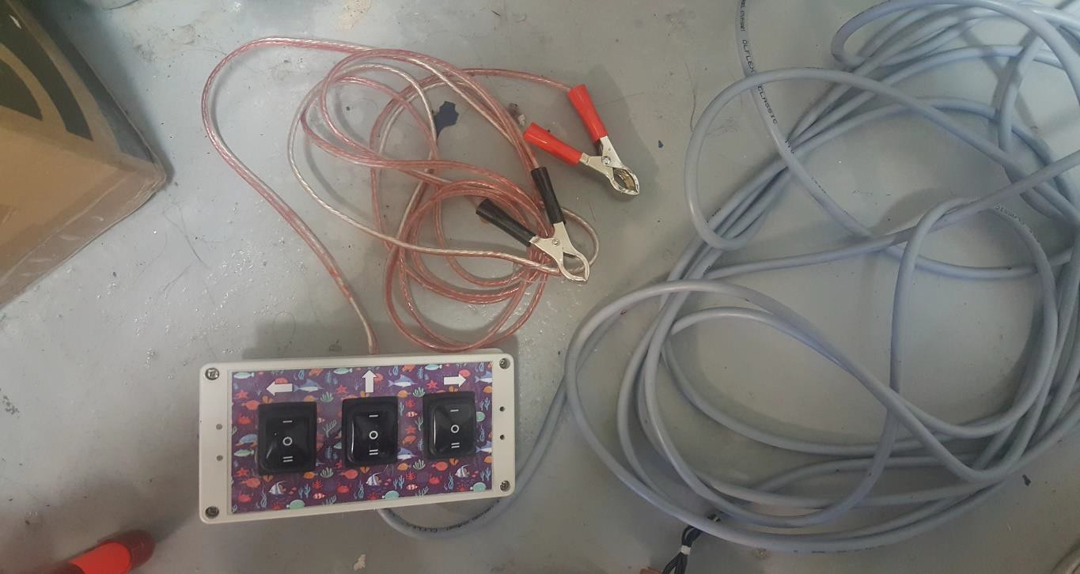

**Photo 3** – A view of the Tether and Motor Cable connected to the control box as well as the power supply cable with the alligator clips

**Spade**

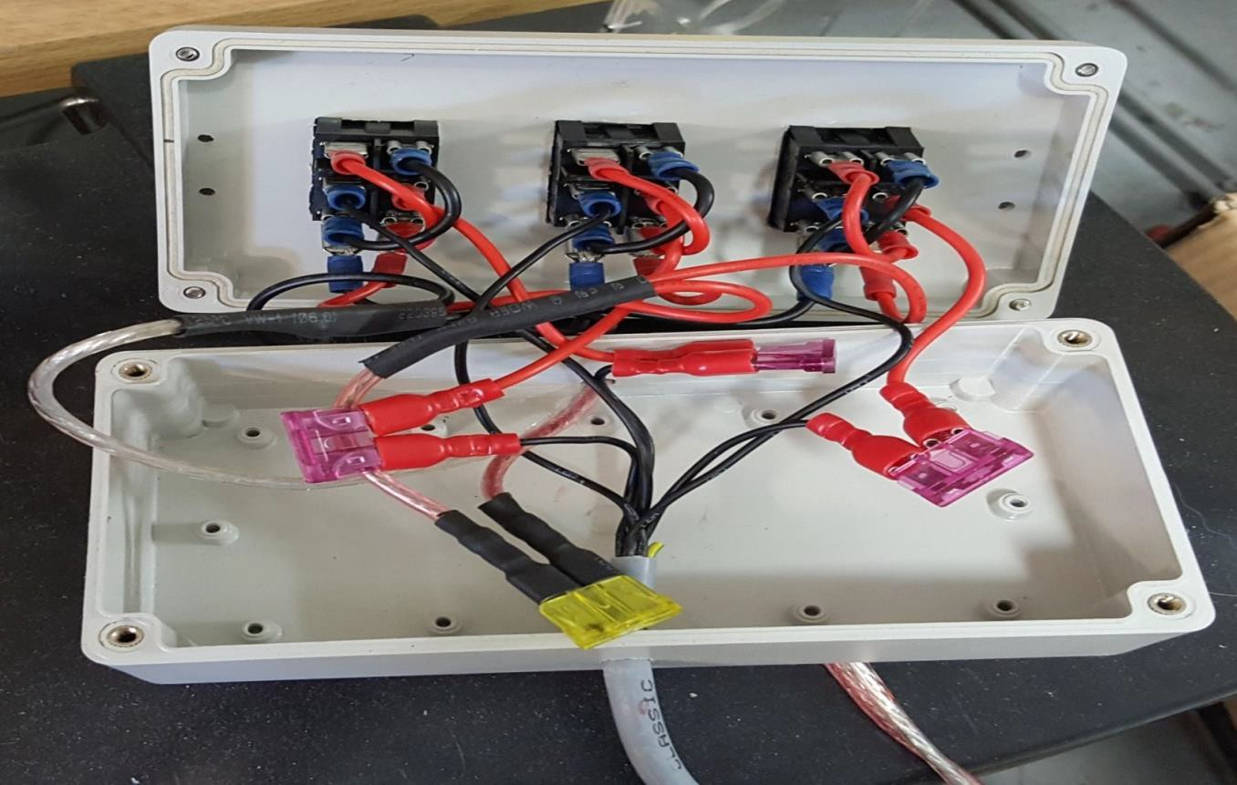

**Switches**

**Open Spade**

**Closed**

**Fuse**

**Tether Cable**

**Photo 4**– A view of the internal component of a completed Control Box

## Procedure 3.1 – Connecting the Tether & Motor to the Control Box

1. 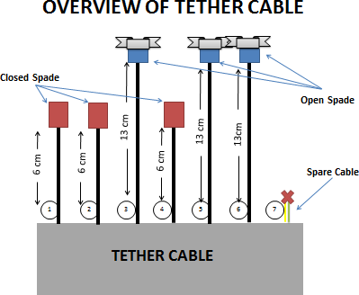Cut open the coat of the Tether Cable that is inside the control box. **(see Photo 4)** and follow the diagram below and cut the cables to the lengths as shown below as well as crimping open / closed spades on to the cable
2. Next prepare the cables as shown below. Note that the Single Double Black and Red Medium cable has a double head.

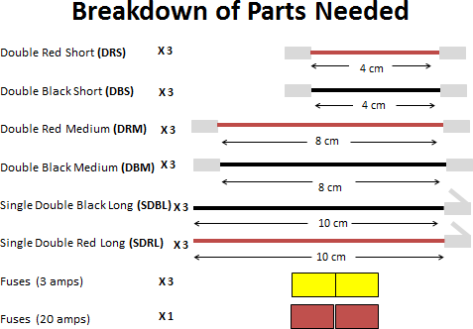

**Photo 5 –** Cables required

1. Once all cables are prepared, you will need to connect the cables to the switches of the control box to control the motor and to provide power. See below for where the cables go. The abbreviations are shown in **Photo 5**

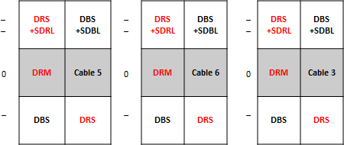

**Switches**

**Power Signal**

**Control Box Case**

1. Now that the cables are plugged into the switch, the next step is to fuse the motor control of the switches to the tether cable. See below

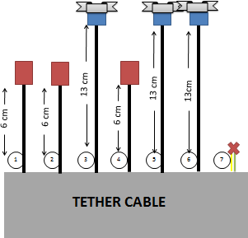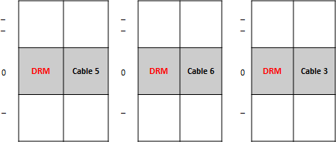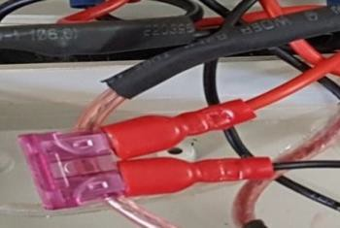

**Fuse (3 amp)**

**Switches**

**Power Signal**

## Procedure 3.2 – Connecting the Power Supply to the Control Box

After the motor of the switches and tether cable are connected, we will need to connect the power supply cables to the switch. This means that the Single Double Red Long (SDRL) & Single Double Black Long (SDBL) cables will need to be connected to the power supply and fuse together. See picture below

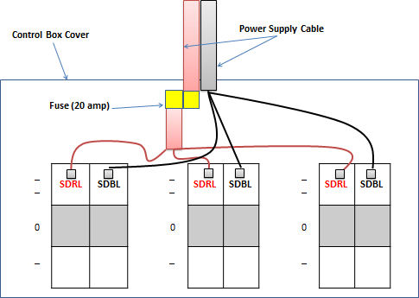

After you completed the steps above, the internal of your control box should look like **Photo 4.**

# Now that your control box is connected to the motors and power supply, you are ready to try out your ROV!

**USING YOUR ROV**

**Safety Precautions**

All ROV operators (pilot and tether manager) as well as water‐side observers should exercise caution and stay aware of the movement of others while near the edge of the pool, dock, or other water‐side location. Even simple inattention to what is going on in the area while focused on operating an ROV can lead to unexpected “dips.” Wearing a personal flotation device is recommended if operating the ROV from a pier that extends into deep water or from a boat (as is often required by law).

Batteries are heavy, and if one is pulled off a tabletop by a tug on the power cord, it can cause an injury (if dropped), as well as damage to the battery. Be careful in battery placement; keeping it on the ground or pool deck.

**Environments Suitable for Using a ROV**

ROVs can be used in fresh water or saltwater, in man‐made pools or natural marine

environments. However, ballasting as well as post‐operation cleaning requirements are different for the two types of environments. Due to the differing water densities, adjustments to the ballast, and to the ROV’s trim, are usually needed when moving from one environment to the other.

For deep water use, the foam floats (which change in buoyancy with depth) should be replaced with solid (non‐compressible) floats.

**Post-Run Cleaning and Maintenance of the ROV System**

**Post‐Run Cleaning.** The ROV should always be rinsed well with fresh water after use. Both pool water and saltwater can be corrosive to thrusters and metal parts. Biologic or other materials picked up in natural marine environments can be damaging and difficult to clean off later if left to dry on the ROV. Besides rinsing the vehicle and cleaning off any debris, it is helpful to submerge it in a tub of fresh water and run the thrusters a bit to better clear corrosive materials from the motor shafts. Allowing the vehicles to dry before storage is recommended. Even if the ROV will be disassembled to have its parts reutilized, having clean parts that are free from corrosive materials and contaminants is important. In such cases, the used thrusters can provide often‐needed spares, so they should be cleaned carefully.

**Battery Maintenance.** Make sure to charge your battery after using it. Lead‐acid batteries will last much longer if they are stored charged.

***Have fun!***